Introduction

Mycobacterium Tuberculosis (TB) was found to have a protein that counteracts with the protein in the macrophage that disrupts the macrophage’s digestive enzymes production. This makes the mycobacteria to reproduce and hide from antibodies formed by the body’s immune system until there is a sufficient amount of the mycobacteria to attack its target organ, the lungs.

Many mycobacteria phages isolated from the environment using mycobacteria Smegmatis as a host have been proven to infect and kill TB. Phage’s lytic cycle involves one phage infecting the host bacteria’s cell machinery producing hundreds of new phages before bursting out and destroying the bacteria cell.

Fluorescent semiconductor nanocrystals, quantum dots (QDs) can be used in phages to be able to trace mycobacteria, the florescent of the QDs will increase when the phage goes through the lytic cycle and starts to rapidly divide. The first step is to produce phages in a limiting biotin (vitamin H) conditions, the progeny phage will be biotinylated from the host cell’s biotin-ligase protein. This step will make only the new progeny of produced phage detectable using QDs while not the phage being injected initially so the location of the host bacteria can be located. The reason QDs would be easily detected is due to the fact that each phage infection will burst the host bacteria cell open with about 100 new phages QD detectable. The detection will happen due to the presence of biotinylated phage particles in the lysate, indicating the presence of the target bacteria, this is detected by conjugation to streptavidin-functionalized QDs
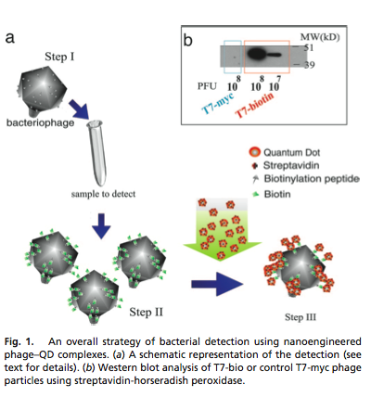
The use of QDs with phages was created to be able to test for the presence of a certain bacteria in a person or not. It was a fast and cheap alternative to the lab methods used that involves growing the bacteria in a culture for several days before being able to test for presence. In this experiment instead I would like to be able to trace QDs of TB infecting phages in a mouse to check for where and when does the number of TB bacteria increase or decrease. So the difference is that I know that these bacteria are in the body (of the mouse) but I’m trying to find the overall path and what happens to the number and location of the TB over time.

Experiment

The idea of the experiment is to be able to trace and estimate the number of bacteria. QDs will be our fluorescent source for us to detect and the phage will be what leads the QD to mycobacterium tuberculosis. The phage will be highly specific for its target which is TB. Since mice are the animals of choice for studying the immunology of mycobacterial infections they will also be our trial animals to be tested on. The plan is to inject both the TB and the phage at different time intervals that will be determined after the initial results of the experiment. The reason why we need to inject a phage into a different mouse every time instead of injecting it once in the beginning with the TB and just tracing it to the end is because the phage will infect and destroy some of the TB bacteria changing the results that would normally occur. So every mouse is only injected once from both the phage and the TB with an exception of one time to test what would happen if only the phage is used.

The quantum dots of CdSe will be used in this experiment as they can be detected via x-rays, other QDs usually require an electron microscopy. To test how long it takes for the phage to start infecting the host mycobacteria, both the TB and the phage will be injected at the exact same time this will give us the time factor to when should we inject the mice further. The object when choosing the different time is to try to find a pattern in which the bacteria decreases or increases within a specific location so such a pattern could be further analyzed for more details.

Discussion

Knowing the exact pathway and when the bacteria starts to rapidly increase can provide a key to a new treatment. There is no precise goal it is an experiment designed for potential discovery and further experiments. If there is a pattern or new discovery about how and where the TB lives in the body since it enters the body we might be able to understand further. The more an organism is studied the more likely you would get a treatment for it. Such an experiment is not time consuming and can provide sufficiently fast results.

One potential problem can be choosing the animal that the experiment to be conducted on as TB might react to it differently than to humans. The human immune system can react completely different than to that of the mouse. Another problem is that the TB might be able to hide or reproduce in a different organ or part of the body than they would do in humans.

The Human Body. ScienceDaily. Retrieved December 2, 2012, from http://www.sciencedaily.com /releases/2008/05/080514134645.htm.

"High-sensitivity Bacterial Detection Using Biotin-tagged Phage and Quantum-dot Nanocomplexes High-sensitivity Bacterial Detection Using Biotin-tagged Phage and Quantum-dot Nanocomplexes

"Detection of Pathogenic Mycobacteria Based on Functionalized Quantum Dots Coupled with Immunomagnetic Separation." PLOS ONE:. N.p., n.d. Web. 02 Dec. 2012. <http://www.plosone.org/article/info:doi/10.1371/journal.pone.0020026>.

National Center for Biotechnology Information. U.S. National Library of Medicine, n.d. Web. 02 Dec. 2012. <http://www.ncbi.nlm.nih.gov/pubmed/16249122>.

"Bacteriophage Amplification for Bacterial Identification | IVD Technology." IVDTechnology RSS. N.p., n.d. Web. 02 Dec. 2012. <http://www.ivdtechnology.com/article/bacteriophage-amplification-bacterial-identification>.

http://www.sciencedirect.com.proxy.library.vcu.edu/science/article/pii/S0003269709000724

